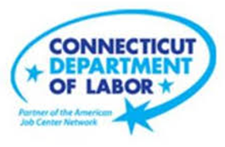

**NEW WEEKLY JOB POSTINGS FROM   
HELP WANTED ONLINE  
Office of Research**

**Week Ending February 19th, 2022: Total New Ads Fall to Second Lowest Level of the Year**  
WETHERSFIELD, February 25th, 2022 – During the week ending February 19th, 2022, there were 5,879 new postings, down -1,436 ads or -20% over the week. Fifty-five percent of this over the week decline occurred in two sectors, Health Care & Social Assistance and Retail Trade. Those two sectors respectively accounted for 30% and 25% of the overall decline. Large over the week employer declines occurred at Amazon (-233 new ads), Starbucks (-52 new ads), Yale-New Haven Health System (-49 new ads) among others. Employers with the largest over the week increases include Avangrid (+104 new ads), Hartford Healthcare (+45 new ads), and the University of Bridgeport (+34 new ads). Connecticut’s 20% over the week decline is twice as large as the 10% U.S.-level drop. When compared to the U.S., the three sectors in Connecticut with the largest declines had proportionally larger swings than corresponding U.S. percent changes. Health Care & Social Assistance (-28% CT, -18% U.S.), Retail Trade (-43% CT, -23% U.S.), and Finance & Insurance (-35% CT, -24% U.S.). The most recent weekly new ad count is the second lowest level since the start of the year, the lowest being 5,246 during the week ending January 1st, 2022.  
   
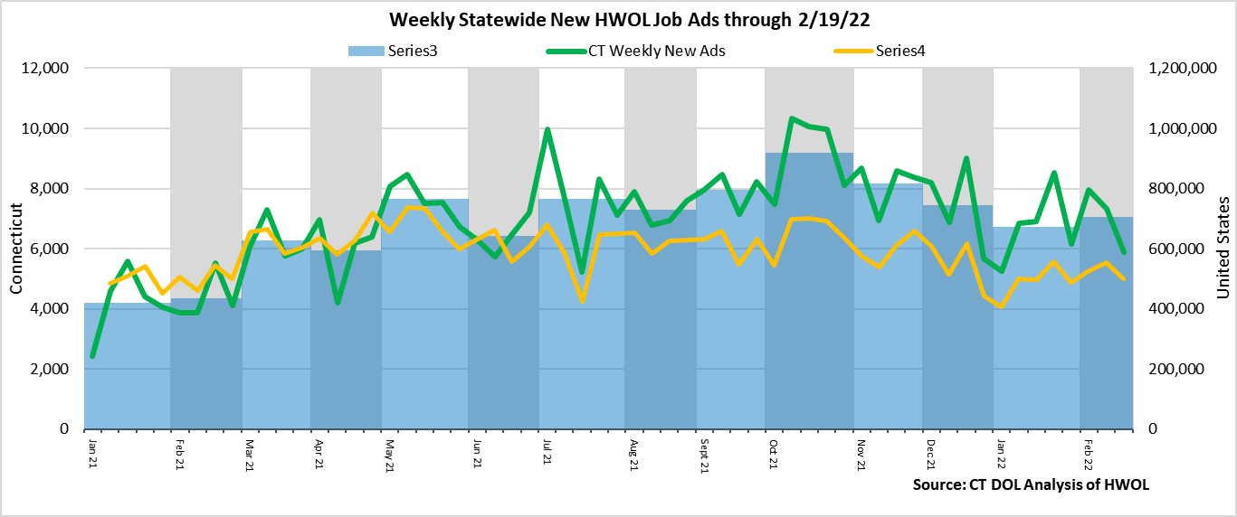

**Industries** with the most new postings include Health Care & Social Assistance, Finance & Insurance, and Retail Trade.

**Occupations** with the most new postings include Registered Nurses, Heavy & Tractor-Trailer Truck Drivers, and Wholesale & Manufacturing Sales Representatives.

**Employers** with the most new postings include Hartford Healthcare, Superior Plus Trucking, and Avangrid.

**The three industries with the most new job postings where:**

* **Health Care & Social Assistance** (1,097 new postings, -28% over the week)
* **Finance & Insurance** (500 new postings, -35% over the week)
* **Retail Trade** (470 new postings, -43% over the week)

   
 11 sectors had job posting increases over the week and 10 had decreases. The 11 increasing sectors grew by a combined 346 new ads and the 10 decreasing sectors fell by a combined 1,782 new ads, resulting in the net decline of 1,436 across all industries. Among the 10 declining industries, 8 had over the week declines of 100 or more. The three largest declines were Health Care & Social Assistance (-433 new ads), Retail Trade (-356 new ads), and Finance & Insurance (-271 new ads). Over Four weeks, the largest industry increase occurred within Transportation & Warehousing (+117 new ads) and the largest decrease occurred in Retail Trade (-877 new ads).   
  
 For more information on total job ads by industry for Connecticut and its labor market areas, see the monthly report available here: <https://www1.ctdol.state.ct.us/lmi/hwol.asp>

**New Job Postings by Occupation** 

**The occupations with the most new postings were:**

* Registered Nurses (290 new postings, -39% over the week)
* Heavy and Tractor-Trailer Truck Drivers (211 new postings, +40% over the week)
* Wholesale & Manufacturing Sales Representatives (139 new postings, -13% over the week)

**Employers with the Most New Job Postings**

Employers with the most new job postings during the week were mostly in Health Care & Social Assistance, Retail Trade, and Finance & Insurance. The 25 employers shown above account for 20 percent of all new ads. Among the top 25 employers, 14 had over the week ad increases and 11 had decreases. The 14 increasing employers had a combined 829 new ads, and the 11 decreasing employers in the top 25 had a combined 384 new ads. The largest increasing employers over the week was Avangrid (+104 new ads), and the largest decreasing employer in the top 25 was Starbucks Coffee (-52 new ads). Over four weeks, 12 employers in the most recent top 25 had increases, one was unchanged, and 12 employers decreased, the largest increase occurred at Superior Plus Trucking (+116 new ads) and the largest four-week decrease occurred at Yale-New Haven Health System (-130 new ads).

**What is HWOL?**The **Conference Board Help Wanted Online**® Data Series (HWOL) measures the number of new, first-time Online job postings and jobs reposted from the previous month for over 16,000 Internet job boards, corporate boards and smaller job sites that serve niche markets and smaller geographic areas. To view more HWOL data, go to: <https://www1.ctdol.state.ct.us/lmi/HWOL2021.pdf>